Integrate Zscaler with Identity Providers (IdPs) such as Azure AD, Okta, and Active Directory for seamless authentication and authorization.

List of teammates:

S.no | Name | Collage | Mail ID
01 | Balamurugan P | Shri Nehru Maha Vidyalaya College of Arts & Science | ragnarok117710@gmail.com
02 | Harini K | Shri Nehru Maha Vidyalaya College of Arts & Science | hariniharini4316@gmail.com
03 | Deepika S.S | Shri Nehru Maha Vidyalaya College of Arts & Science | edeepika0180@gmail.com
04 | Akshaya N | Shri Nehru Maha Vidyalaya College of Arts & Science | akshayakavitha58@gmail.com
05 | Harivarthan S | Shri Nehru Maha Vidyalaya College of Arts & Science | harivarthan200@gmail.com

Introduction
Modern organizations rely heavily on cloud applications and remote access technologies. As employees, students, and administrators work from different locations, securing access to sensitive resources has become a critical challenge. Traditional security models that depend on network-based trust and VPN access often create security risks because users are granted broad network access after authentication.
This project focuses on integrating the cloud security platform Zscaler with enterprise Identity Providers such as Microsoft Entra ID, Okta, and Active Directory. The integration enables centralized identity management where authentication and authorization decisions are based on verified user identities rather than network location.
By connecting Zscaler with these identity providers, organizations can enforce secure access policies, implement Single Sign-On (SSO), and ensure that only authenticated users can access internal applications and internet services. This approach simplifies user authentication while improving security by eliminating multiple login credentials and reducing administrative overhead.
The integration also supports advanced security mechanisms such as Multi-Factor Authentication (MFA), automated user provisioning, and role-based access control. These capabilities help organizations create a secure and efficient authentication framework that supports modern work environments.
Ultimately, the project demonstrates how identity-based security models can enhance network protection while improving the user experience for employees and administrators.

Abstract:
With the increasing adoption of cloud computing and remote work environments, traditional security approaches are no longer sufficient to protect organizational resources. Modern security strategies emphasize identity-based access control, where user identity becomes the primary factor for authentication and authorization.
This project explores the integration of Zscaler security services with enterprise Identity Providers including Microsoft Entra ID, Okta, and on-premises Active Directory. The goal is to establish a unified authentication mechanism that allows users to securely access applications and network services through a single trusted identity platform.
The integration utilizes modern authentication protocols such as Security Assertion Markup Language (SAML), OpenID Connect (OIDC), and System for Cross-domain Identity Management (SCIM). These protocols enable secure communication between the identity provider and the Zscaler platform, allowing organizations to authenticate users through centralized directories.
By implementing Single Sign-On (SSO), users can access multiple services using a single login, reducing password fatigue and improving productivity. Additionally, Multi-Factor Authentication (MFA) strengthens security by requiring additional verification methods during login attempts.
This project highlights the advantages of identity-driven security architectures and demonstrates how integrating cloud security platforms with identity providers can create a scalable and secure access control system suitable for modern enterprises.

Use Case Scenarios:
Scenario 1: Remote Faculty Access To Research Data
A company employee working from home needs access to internal company applications such as file servers or project management tools. Instead of connecting through a traditional VPN, the user authenticates using the organization’s identity provider. Once authenticated, Zscaler verifies the user identity and grants secure access only to authorized applications.
Output:
- Identity verification through Identity Provider
- Secure application access
- Multi-factor authentication enforcement
- Restricted network visibility
Scenario 2: Student Access to Library Resources
Students often require remote access to digital libraries, academic portals, and internal learning platforms. Through integration with identity providers such as Microsoft Entra ID, students can log in using their university credentials. Zscaler ensures that only authorized students gain access to licensed academic resources.
Output:
- Verified student identity
- Controlled access to learning portals
- Secure remote connectivity
- Simplified login experience
Scenario 3: HR Administrator Access to Payroll System
In this scenario, the HR administrator logs into the organization’s system using an identity provider such as Microsoft Entra ID, Okta, or Active Directory. After successful authentication, the access request is verified by Zscaler, which checks whether the user has the appropriate role and permissions to access the payroll application.
By integrating identity providers with Zscaler, organizations can ensure secure and controlled access to payroll systems while protecting sensitive employee information from unauthorized users.
Output:
- Role-based access to payroll system
- Secure authentication through identity provider
- Multi-Factor Authentication verification
- Monitoring and logging of administrator activities
Scenario 4: IT Helpdesk Remote Troubleshooting
In this scenario, the helpdesk engineer first authenticates using an identity provider like Microsoft Entra ID, Okta, or Active Directory. After successful authentication, Zscaler verifies the user identity and grants controlled access only to the required system or application for troubleshooting. Security mechanisms such as Multi-Factor Authentication (MFA) and role-based access control ensure that the IT staff can perform support tasks securely without exposing other sensitive resources in the organization’s network.
Output:
- Secure authentication through Identity Provider
- Restricted access to specific systems for troubleshooting
- Multi-Factor Authentication verification
- Monitoring and logging of helpdesk activities
Scenario 5: Contractor Access to Project Management Tool
Since contractors are not permanent employees, their access must be carefully controlled to protect sensitive company data. In this scenario, the contractor authenticates through an identity provider such as Microsoft Entra ID, Okta, or Active Directory. After successful authentication, Zscaler verifies the user identity and applies access policies to ensure the contractor can only access the specific project management application required for their work. This approach helps organizations maintain secure collaboration with external users while protecting internal systems.

Output:
- Secure authentication for contractor through Identity Provider
- Limited access to project management tools
- Role-based access control for external users
- Monitoring and logging of contractor activities

Stage – 1

Title of the project:
Integrate Zscaler with Identity Providers (IdPs) such as Azure AD, Okta, and Active Directory for seamless authentication and authorization.

Overview:

The Network Management (NM) project focuses on implementing a secure and efficient authentication system by integrating Zscaler with identity providers such as Microsoft Entra ID, Okta, and Active Directory. In modern organizations, employees and users often access applications and data from different locations and devices, which creates security challenges for IT administrators. Traditional security methods like VPN-based access provide broad network access after authentication, which can increase the risk of unauthorized activities.
This project demonstrates how identity-based security can improve protection by verifying user identity before granting access to applications or services. By integrating Zscaler with identity providers, users can securely log in through a centralized authentication system. Technologies such as Single Sign-On (SSO) and Multi-Factor Authentication (MFA) help ensure that only authorized users can access specific resources within the network.
The system also applies role-based access control, which means users are granted permissions based on their job roles, such as HR administrators, IT helpdesk staff, or contractors. Additionally, all access activities are monitored and logged to maintain transparency and improve security management. Overall, this project highlights how integrating cloud security platforms with identity providers helps organizations implement a Zero Trust security model, providing secure, scalable, and efficient access control for modern digital environments.

List of Vulnerability:

S.no | Category | Vulnerability Name | CWE/CVE - No
O1 | Broken Access Control | Improper Access Control | 284
02 | Security Misconfiguration | Insufficient Session Expiration | 613
03 | Software Supply Chain Failures | Insecure Temporary File | 377
04 | Cryptographic Failures | Incorrect Default Permissions | 276
05 | Injection | Unverified Ownership | 283
06 | Insecure Design | Configuration | 16
07 | Authentication Failures | Weak Password requirments | 521
08 | Software or Data Integrity Failures | Improper Privilege Management | 269
09 | Security Logging and Alerting Failures | Insufficient Logging | 778
10 | Mishandling of Exceptional Conditions | Unimplemented or Unsupported Feature in UI | 447

REPORT
1) Vulnerability Name: Insufficient Session Expiration
CWE/CVE: CWE-613
OWASP/SANS Category: A02:2025 – Security Misconfiguration
Description:Session tokens remain valid for a long time after user inactivity or logout. Attackers who obtain the session token can reuse it to gain unauthorized access.
Business Impact: Attackers may hijack user sessions and access protected resources.
Recommendation:
- Implement automatic session timeout.
- Invalidate session after logout.
- Use secure cookies and session management.
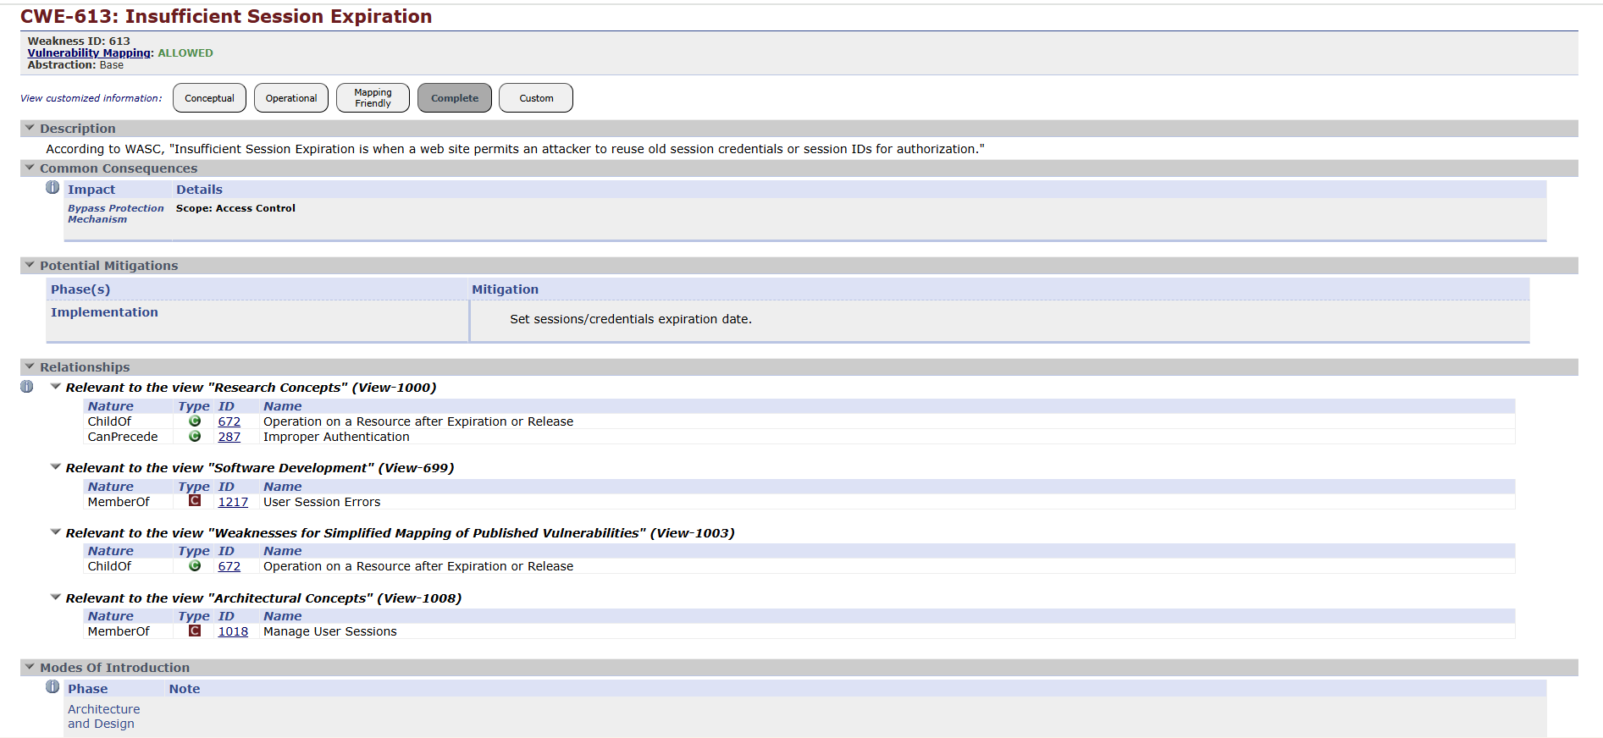

2) Vulnerability Name: Improper Access Control
CWE/CVE: CWE-284
OWASP/SANS Category: Broken Access Control
Description: Improper access control occurs when systems fail to correctly enforce restrictions on authenticated users. In identity-based systems, users may accidentally receive permissions beyond their job roles due to configuration errors or lack of role-based access policies. This can allow unauthorized viewing or modification of sensitive information.
Business Impact: Employees or attackers may gain access to confidential data, administrative functions, or restricted applications, which can compromise organizational security.
Recommendation:
- Implement Role-Based Access Control (RBAC).
- Define proper user roles and permissions.
- Regularly review access privileges.
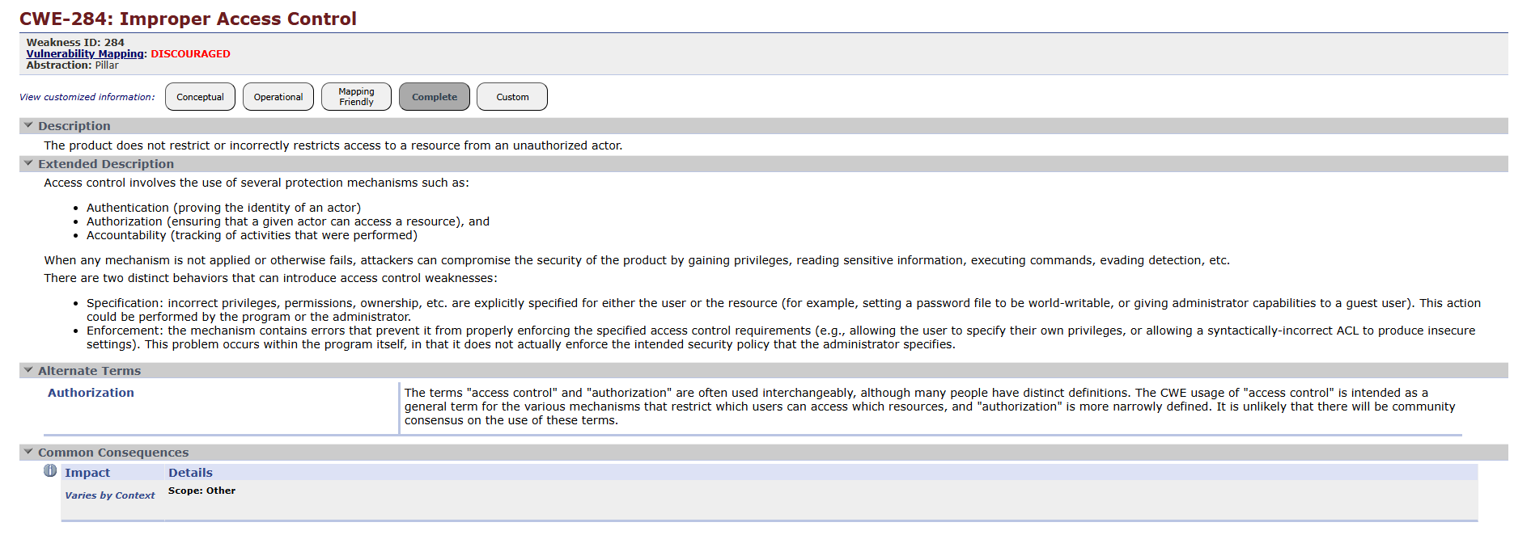
3) Vulnerability Name: Unimplemented or Unsupported Feature in UI
CWE/CVE: CWE-447
OWASP/SANS Category:Mishandling of Exceptional Conditions
Description: This vulnerability occurs when a user interface provides options or features that are not fully implemented or supported by the system. Attackers may interact with these incomplete features to trigger unexpected behavior, bypass security controls, or exploit system errors.
Business Impact: Attackers may exploit unsupported features to cause system crashes, gain unauthorized access, or manipulate system operations.
Recommendation:
- Remove unused or incomplete UI features.
- Ensure all interface options are properly implemented and tested.
- Validate user actions before processing them in the system.
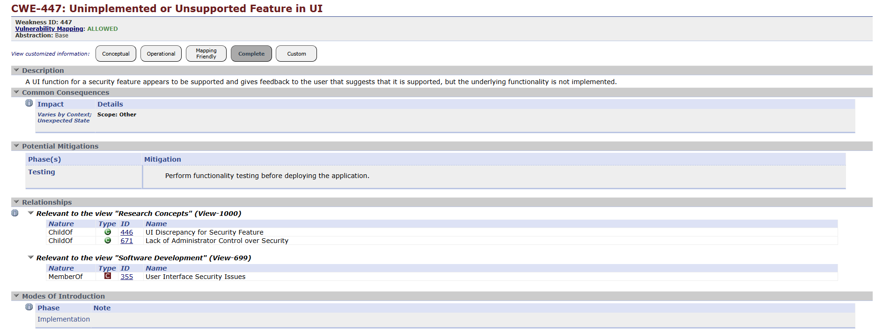
- Vulnerability Name: Incorrect Default Permissions
CWE/CVE: CWE-276
OWASP/SANS Category: A02:2025 – Security Misconfiguration
Description: This vulnerability occurs when files, directories, or system resources are created with overly permissive default access rights. If default permissions allow unauthorized users to read, modify, or execute files, attackers may exploit these permissions to gain access to sensitive information or modify system configurations.
Business Impact: Attackers may access confidential data, alter system files, or escalate privileges within the system, potentially leading to system compromise.
Recommendation:
- Configure secure default permissions for files and directories.
- Follow the principle of least privilege.
- Regularly audit and update access control permissions.
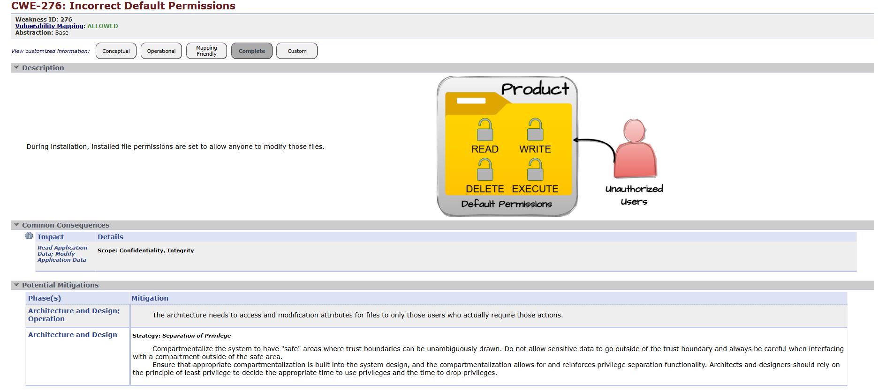

5) Vulnerability Name:Improper Privilege Management
CWE/CVE: CWE-269
OWASP/SANS Category: Broken Access Control
Description: Improper Privilege Management occurs when a user gains higher access rights than originally granted. This vulnerability may occur due to improper access configuration or security flaws within authentication systems.
Business Impact: Attackers or internal users may gain administrative privileges, allowing them to modify system configurations, access sensitive data, or disrupt business operations.
Recommendation:
- Apply strict role-based permission policies.
- Monitor privilege changes.
- Restrict administrative access.
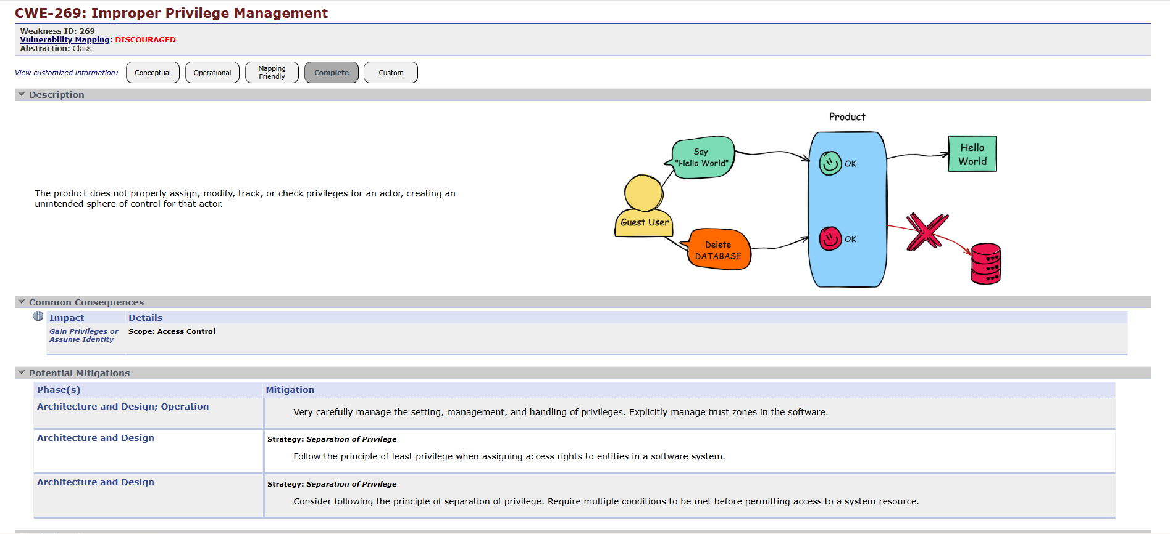

6) Vulnerability Name: Configuration
CWE/CVE: CWE-16
OWASP/SANS Category: Security Misconfiguration
Description:Configuration vulnerabilities occur when systems, applications, or security services are not properly configured. Incorrect settings, default credentials, or exposed services may allow attackers to gain unauthorized access to the system.
Business Impact: Improper configuration may lead to unauthorized access, exposure of sensitive data, or system compromise.
Recommendation:
- Apply secure configuration guidelines.
- Remove default credentials.
- Disable unnecessary services and ports.
- Perform regular security configuration audits..
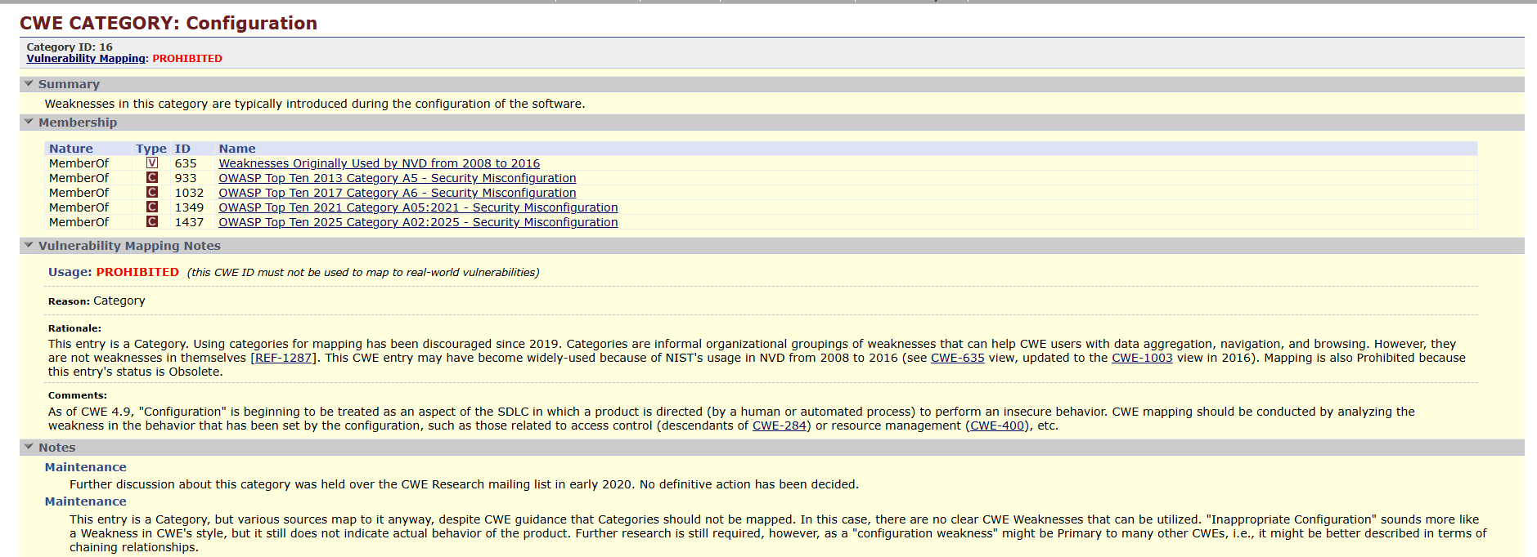

7) Vulnerability Name: Insufficient Logging
CWE/CVE: CWE-778
OWASP/SANS Category: Security Logging
Description: Systems that do not properly log authentication activities may fail to detect suspicious behavior such as repeated login failures, unusual login locations, or unauthorized access attempts. Without proper monitoring, attackers may remain undetected for long periods.
Business Impact: Delayed detection of cyber attacks can result in severe security incidents, data loss, and operational disruption.
Recommendation:
- Enable centralized logging systems.
- Monitor login activities.
- Set alerts for suspicious behavior.
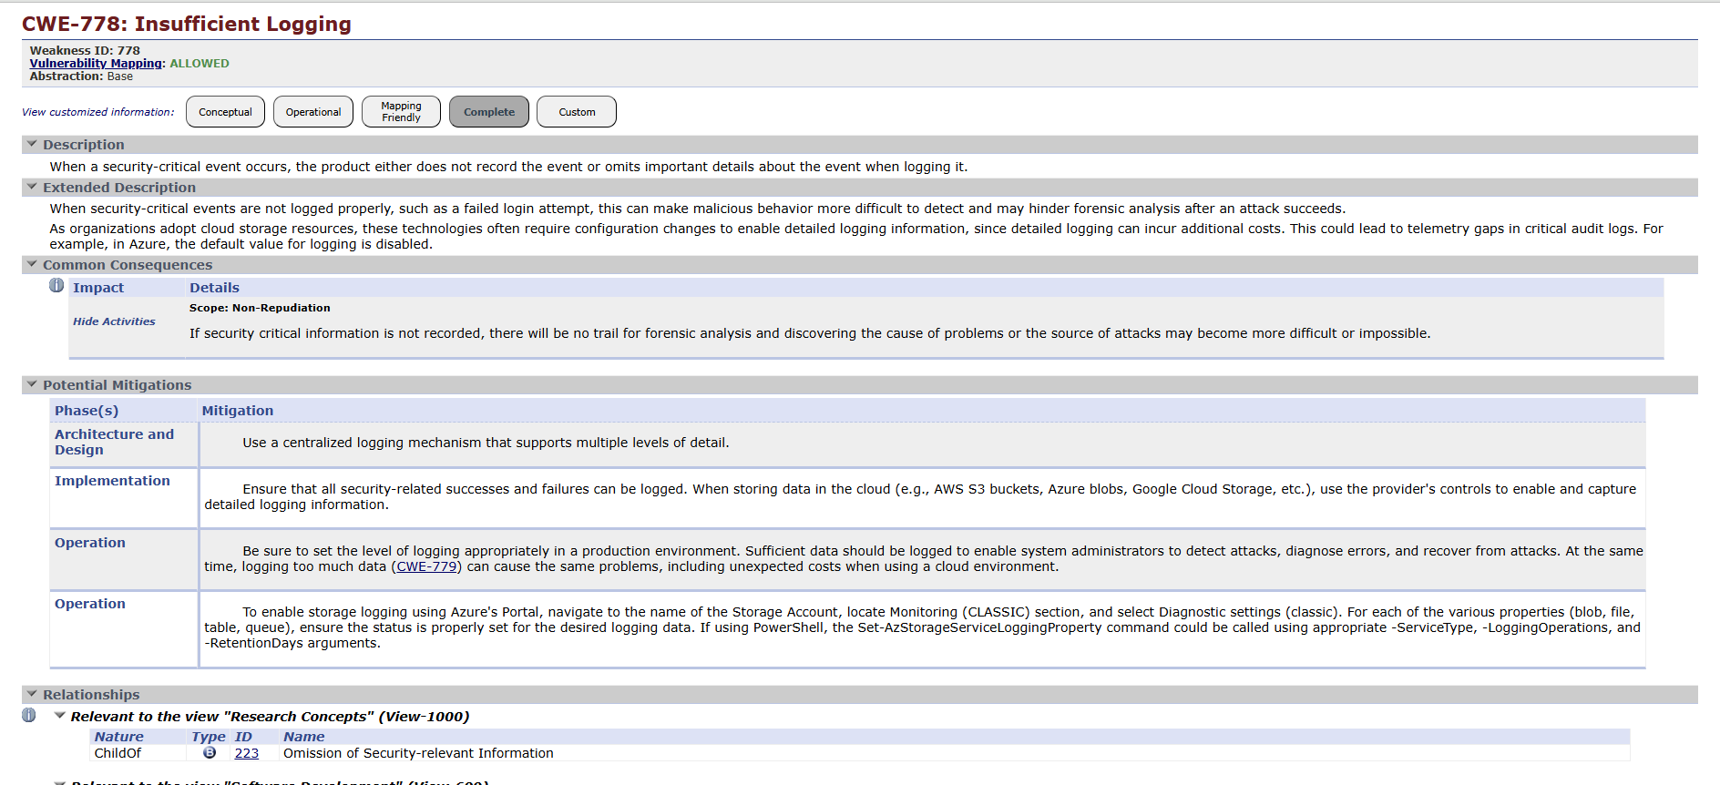

8) Vulnerability Name:Unverified Ownership
CWE/CVE: CWE-283
OWASP/SANS Category: A01:2025 – Broken Access Control
Description:Unverified Ownership occurs when a system does not properly verify whether a user owns or is authorized to access a particular resource before allowing an operation. Attackers may manipulate object identifiers such as file IDs, user IDs, or resource references to access or modify data belonging to other users.
Business Impact:Unauthorized users may gain access to confidential information, modify data belonging to other users, or perform unauthorized actions in the system.
Recommendation:
- Verify resource ownership before granting access.
- Implement strong authorization checks.
- Apply Role-Based Access Control (RBAC).
- Validate user identity before processing requests.
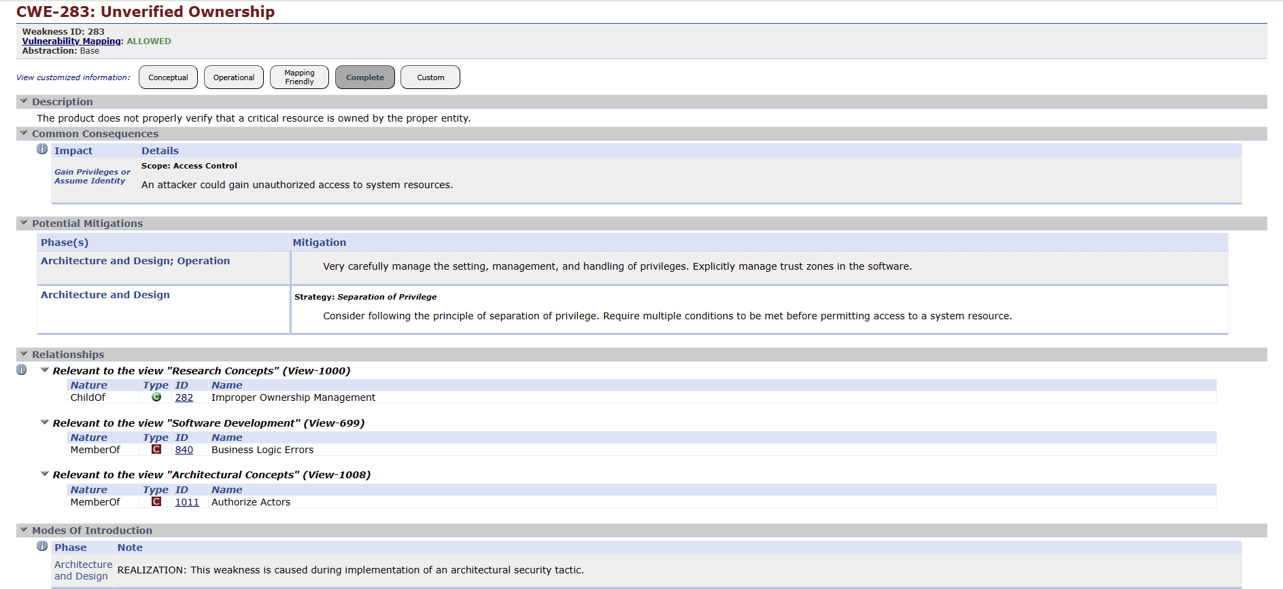

9) Vulnerability Name: Insecure Temporary File
CWE/CVE: CWE-377
OWASP/SANS Category:A02:2025 – Security Misconfiguration
Description:This vulnerability occurs when an application creates temporary files in an insecure manner. Temporary files may be stored in shared or publicly accessible directories with improper permissions. Attackers may access, modify, or replace these files to obtain sensitive information or interfere with application processes.
Business Impact: Sensitive data stored in temporary files may be exposed to unauthorized users. Attackers may also manipulate temporary files to alter system behavior or gain unauthorized access.
Recommendation:
- Store temporary files in secure directories.
- Apply strict file permission controls.
- Delete temporary files immediately after use.
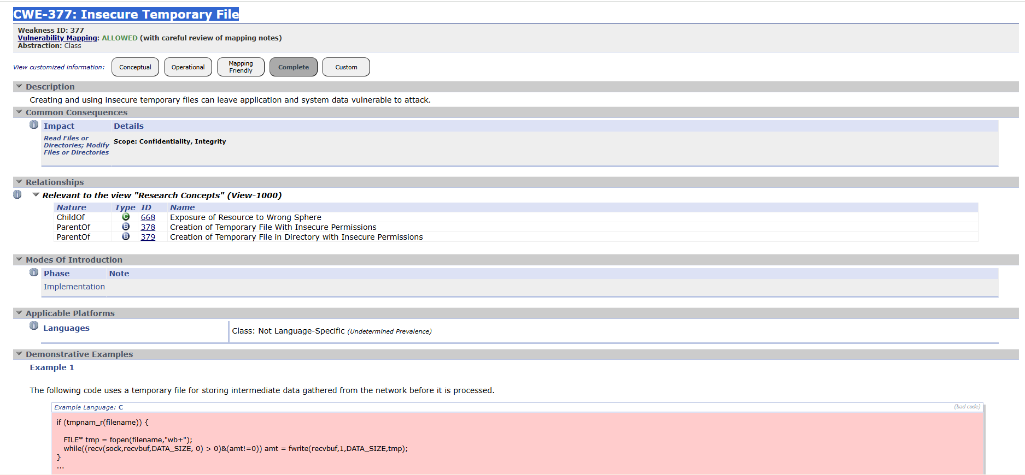

10) Vulnerability Name: Weak Password requirments
CWE/CVE: CWE-521
OWASP/SANS Category: A07 Authentication Failures
Description: Weak password requirements allow users to create simple or easily guessable passwords. Without strong password requirements such as minimum length, special characters, and periodic updates, attackers can perform brute-force or dictionary attacks to compromise accounts.
Business Impact: Compromised user accounts can lead to unauthorized system access, data leakage, and potential security breaches.
Recommendation:
- Enforce strong password policies.
- Require minimum password length and complexity.
- Implement periodic password changes.
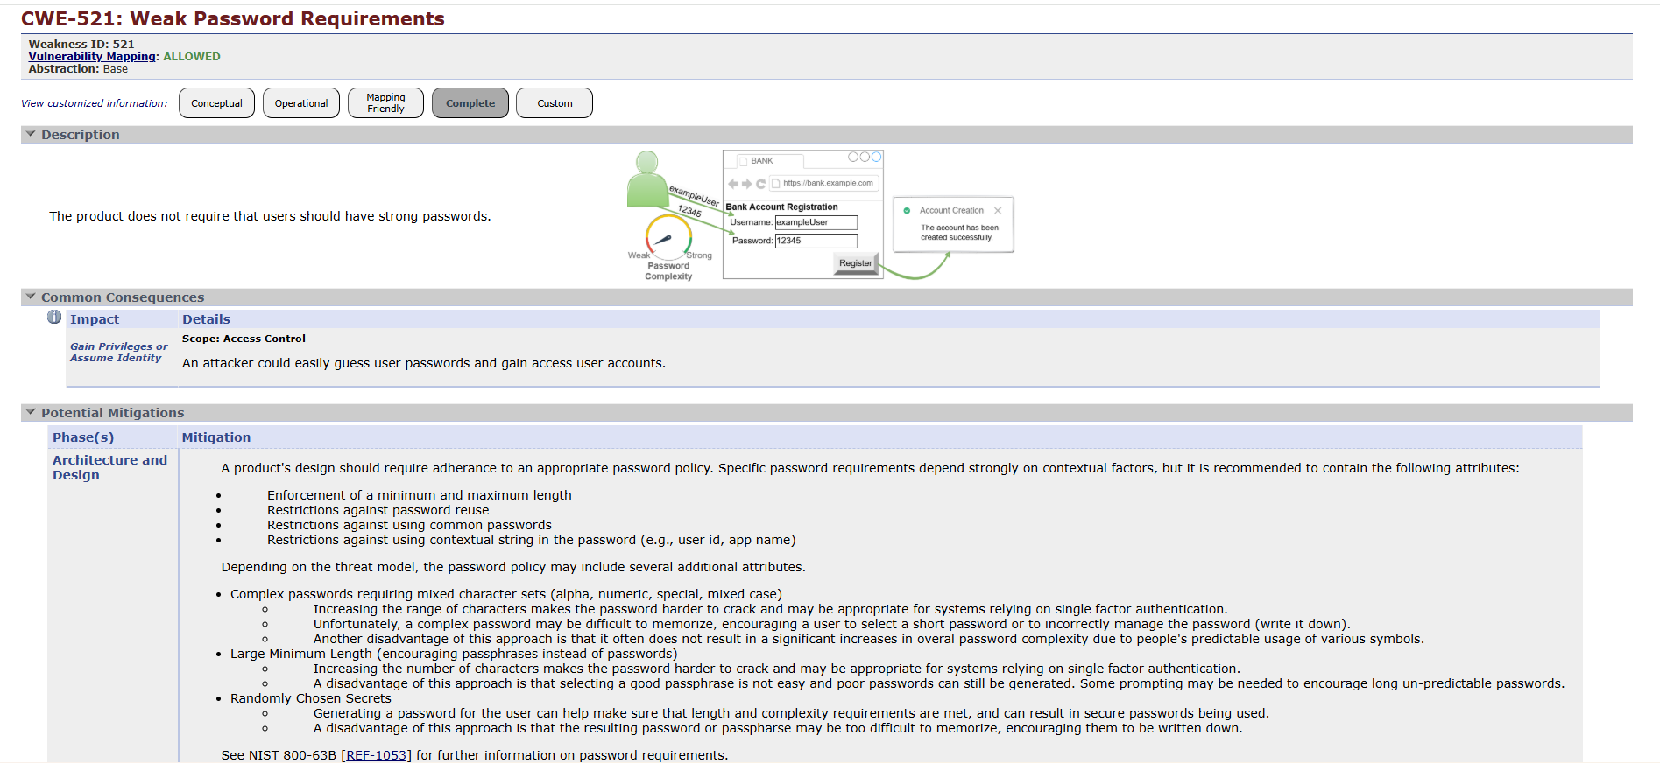

Stage – 2

Title of the project:
Integrate Zscaler with Identity Providers (IdPs) such as Azure AD, Okta, and Active Directory for seamless authentication and authorization.

Overview:
Nessus is a popular vulnerability assessment tool developed by Tenable. It is used by security professionals to identify weaknesses in computer systems, servers, and web applications.
Nessus performs remote vulnerability scanning, meaning it does not need to be installed on the target machine. Instead, it sends various network requests to the target host and analyzes the responses to detect potential security vulnerabilities.
The tool works using a plugin-based architecture, where each plugin is designed to check for a specific type of vulnerability such as outdated software, insecure configurations, weak encryption protocols, or exposed services. Nessus maintains a large plugin database that allows it to detect thousands of known security issues.
During a scan, Nessus first performs host discovery to identify the target system and gather basic information such as operating system details and running services. After collecting this information, the scanner performs multiple vulnerability tests to determine whether the system contains any known security weaknesses.
Once the scanning process is completed, Nessus generates a comprehensive vulnerability report that includes severity levels, descriptions of vulnerabilities, and recommended remediation steps.

Scanning Capabilities
Nessus can scan a wide range of targets including:
- Individual computers and servers
- Entire network infrastructures
- Web applications and services
- Specific ports and running services
Scans can be performed manually or scheduled automatically, allowing continuous monitoring of system security.

Working Process of Nessus
The vulnerability scanning process using Nessus involves the following steps:
1. Connection Establishment
Nessus establishes communication with the target host using protocols such as TCP, UDP, and ICMP.
2. System Discovery
The scanner identifies the operating system, open ports, and services running on the target machine.
3. Vulnerability Analysis
Nessus runs multiple security plugins to check for known vulnerabilities and misconfigurations.
4. Report Generation
After the analysis, Nessus generates a detailed report that shows vulnerability severity, description, and recommended solutions.

Advantages of Using Nessus
• Large vulnerability database capable of detecting thousands of security flaws.
• User-friendly interface that simplifies scan configuration and report analysis.
• Detailed security reports including severity levels and remediation steps.
• Scalable scanning capability for single hosts, networks, or web applications.
• Flexible scan scheduling allowing both manual and automated scans.

Target Details
Target Website:
http://zero.webappsecurity.com
Target IP Address:
54.82.22.214

NESSUS SCAN REPORT :
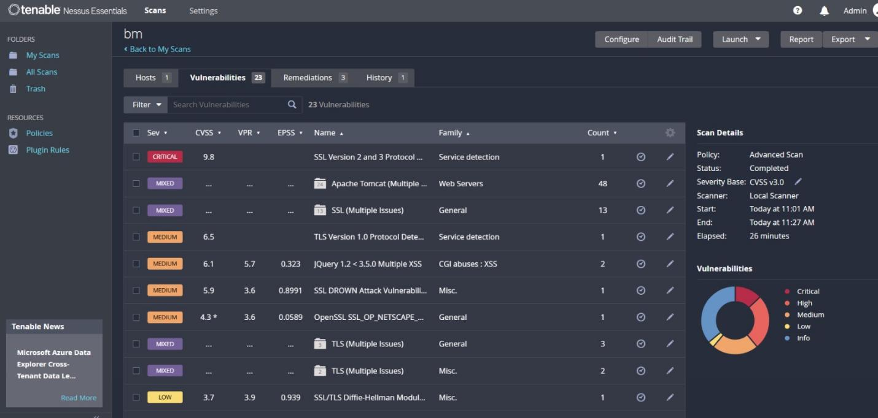
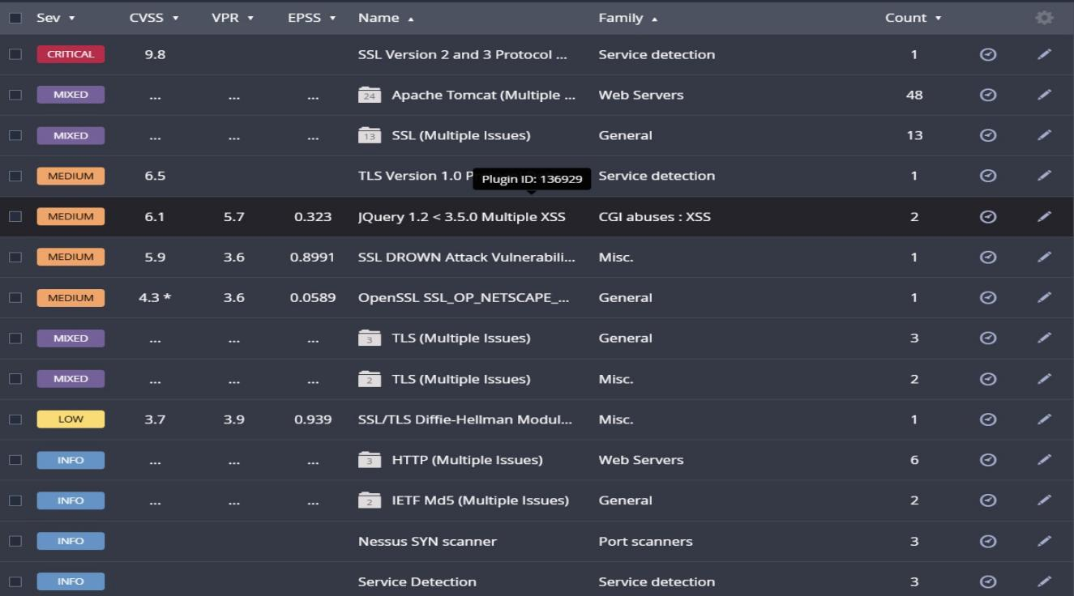
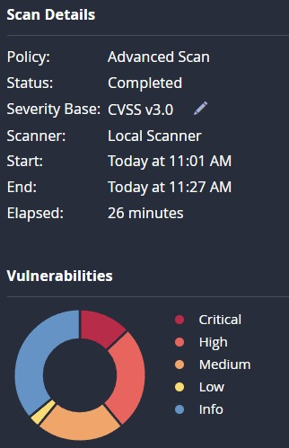

List of Vulnerability :

S.no | Vulnerability Name | Severity | Plugins ID
1 | Nessus SYN Scanner | Info | 11219
2 | Service Detection | Info | 22964
3 | jQuery Detection | Info | 106658
4 | Aditional DNS Hostnames | Info | 46180
5 | Nessus scan information | Info | 19506
6 | OS Fingerprints Detected | Info | 209654
7 | Patch Report | Info | 66334
8 | Traceroute information | Info | 10287

1. Nessus SYN Scanner
Vulnerability Name:
Nessus SYN Scanner
Severity:
Info
Plugin:
11219
Port:
Multiple Ports
Description:
The SYN scanner is used to detect open ports on the target system. It sends SYN packets to the target host and analyzes responses to identify active services. This technique is commonly used during vulnerability assessment to gather information about exposed services.
Solution:
Configure firewalls and intrusion detection systems (IDS) to monitor and restrict unauthorized port scanning activities. Network administrators should ensure that only necessary ports are open.
Business Impact:
Attackers may use port scanning techniques to discover open services and identify potential attack points within the system.
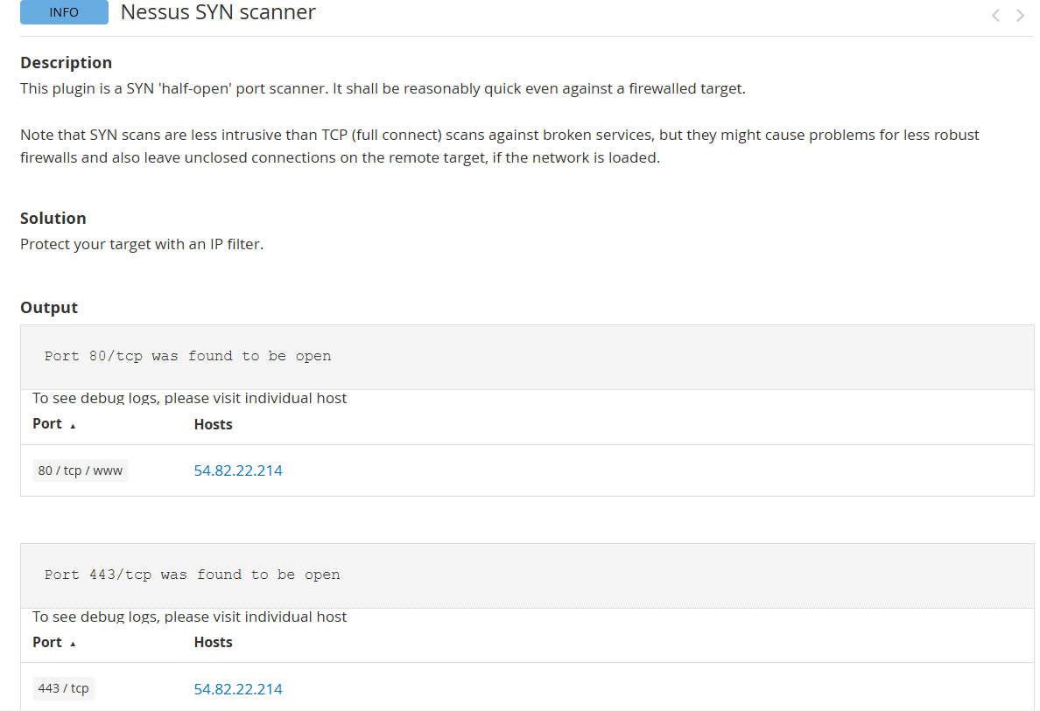

2. Service Detection
Vulnerability Name:
Service Detection
Severity:
Info
Plugin:
22964
Port:
Multiple Ports
Description:
This plugin detects services running on open ports of the target system. Identifying services helps security professionals understand what applications are exposed to the network.
Solution:
Disable unnecessary services and ensure that required services are properly configured and regularly updated with security patches.
Business Impact:
Exposure of unnecessary services increases the attack surface and may allow attackers to exploit vulnerabilities in outdated services.
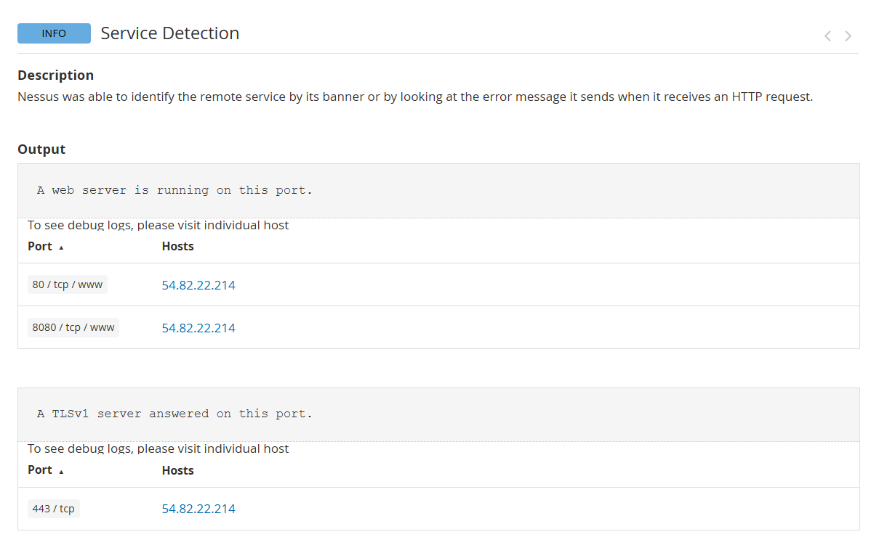

3. jQuery Detection
Vulnerability Name:
jQuery Detection
Severity:
Info
Plugin:
106658
Port:
80 / 443
Description:
The scanner detected the presence of the jQuery JavaScript library on the web application. Older versions of jQuery may contain security vulnerabilities that attackers could exploit.
Solution:
Update the jQuery library to the latest secure version and regularly monitor for security updates.
Business Impact:
Outdated JavaScript libraries may expose the application to client-side attacks such as Cross-Site Scripting (XSS).
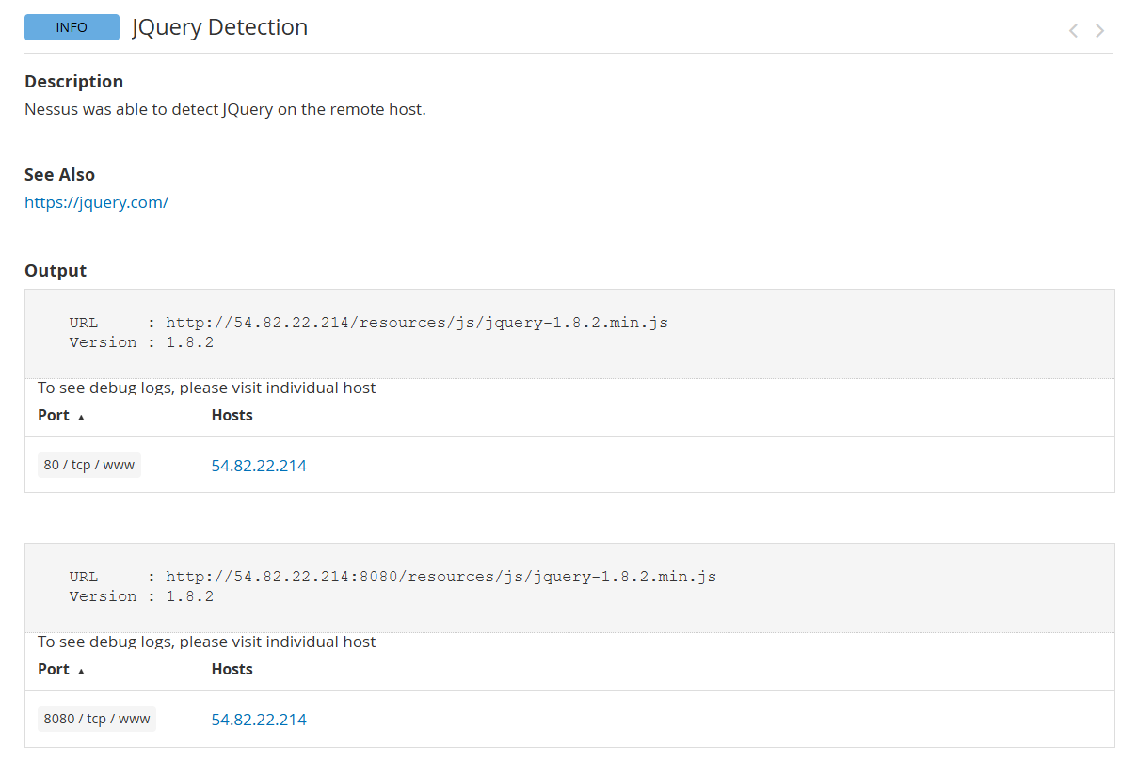

4. Additional DNS Hostnames
Vulnerability Name:
Additional DNS Hostnames
Severity:
Info
Plugin:
46180
Port:
53
Description:
The scan identified additional DNS hostnames associated with the target system. These hostnames may reveal additional infrastructure details.
Solution:
Review DNS configurations and remove unnecessary or unused hostnames to reduce information disclosure.
Business Impact:
Attackers may use DNS information to map network infrastructure and identify additional targets.
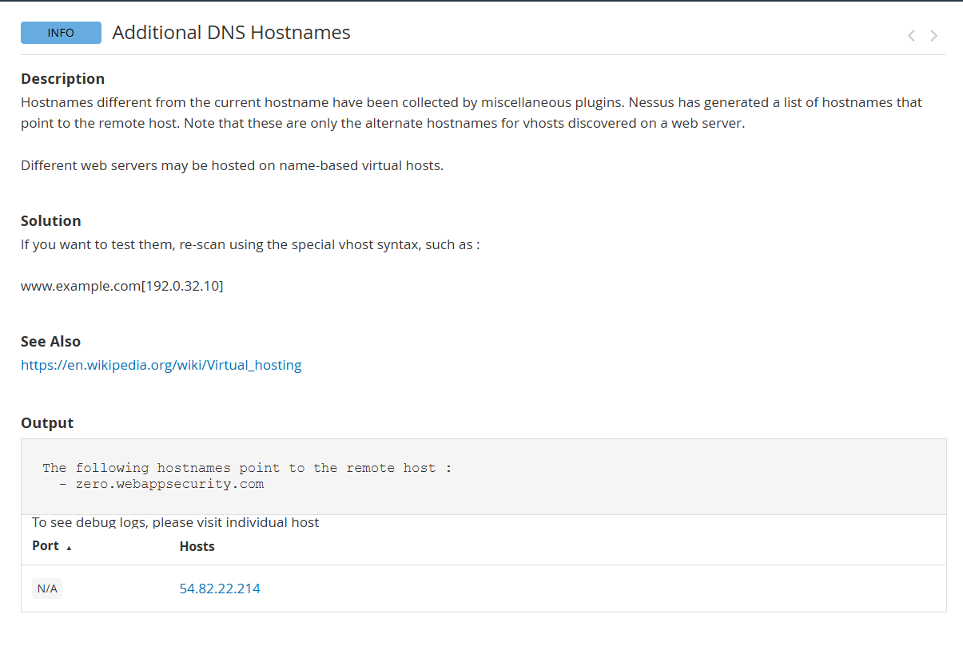

5. Nessus Scan Information
Vulnerability Name:
Nessus Scan Information
Severity:
Info
Plugin:
19506
Port:
N/A
Description:
This plugin provides general information about the scan, including the scan start time, scanner version, and scanning configuration.
Solution:
No action is required. This plugin is informational and used for documentation purposes.
Business Impact:
There is no direct security impact as this entry only provides scan-related details.
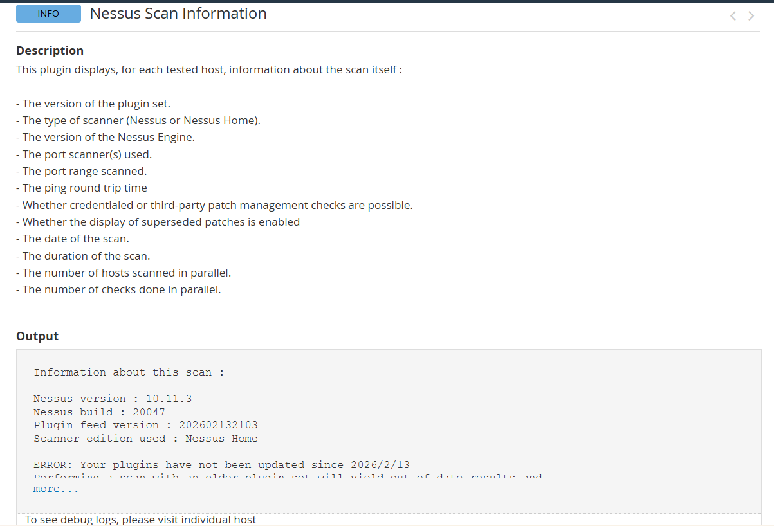

6. OS Fingerprints Detected
Vulnerability Name:
Operating System Fingerprinting
Severity:
Info
Plugin:
209654
Port:
Multiple Ports
Description:
The scanner identified the operating system running on the target host by analyzing network responses. OS fingerprinting helps identify system characteristics.
Solution:
Implement network security controls such as firewalls and intrusion prevention systems to limit system fingerprinting attempts.
Business Impact:
Attackers may use OS information to launch targeted attacks against known vulnerabilities of that operating system.
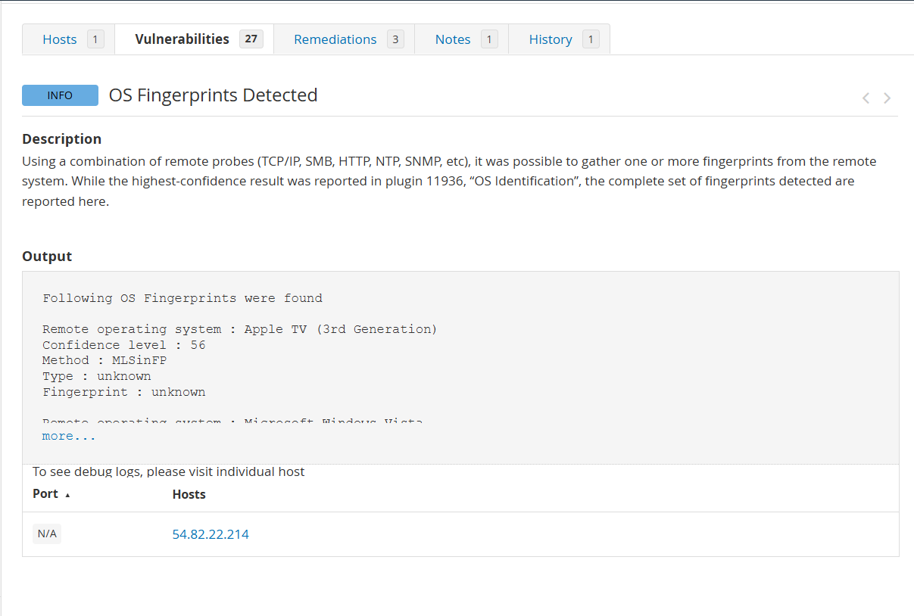

7. Patch Report
Vulnerability Name:
Patch Report
Severity:
Info
Plugin:
66334
Port:
N/A
Description:
This report provides information about missing or installed security patches on the system.
Solution:
Ensure all operating systems and applications are updated regularly with the latest security patches.
Business Impact:
Unpatched systems may contain vulnerabilities that attackers can exploit to compromise the system.
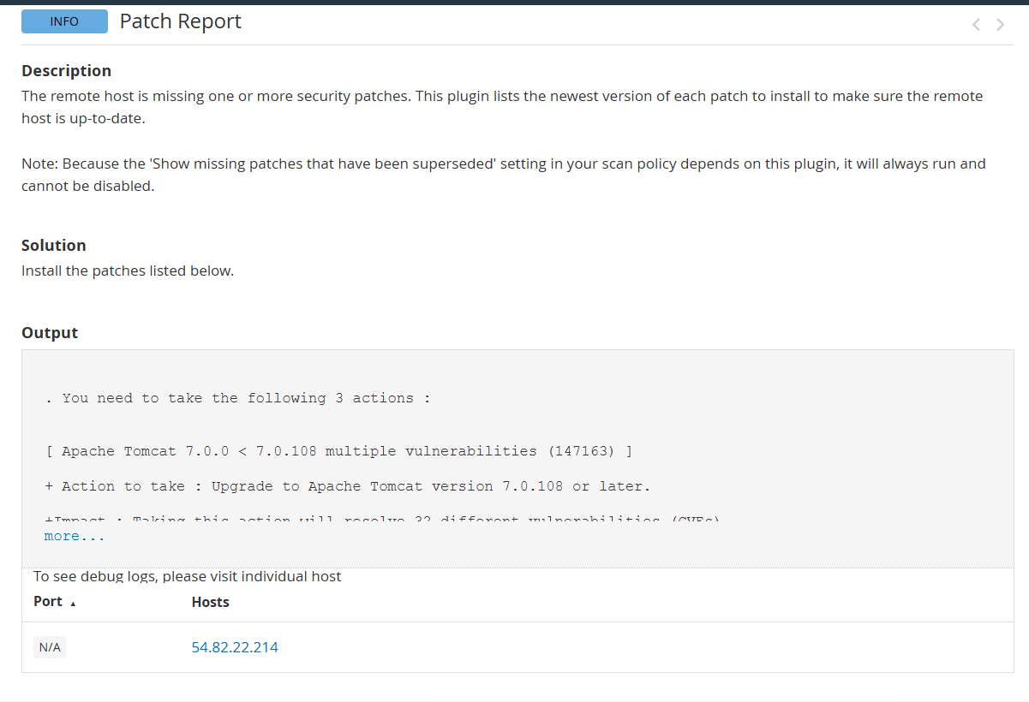

8. Traceroute Information
Vulnerability Name:
Traceroute Information
Severity:
Info
Plugin:
10287
Port:
N/A
Description:
Traceroute information identifies the network path between the scanner and the target host. It helps analyze network routing and connectivity.
Solution:
Restrict ICMP responses and configure network security devices to limit exposure of network routing details.
Business Impact:
Attackers may use traceroute results to map the network infrastructure and identify potential attack paths.
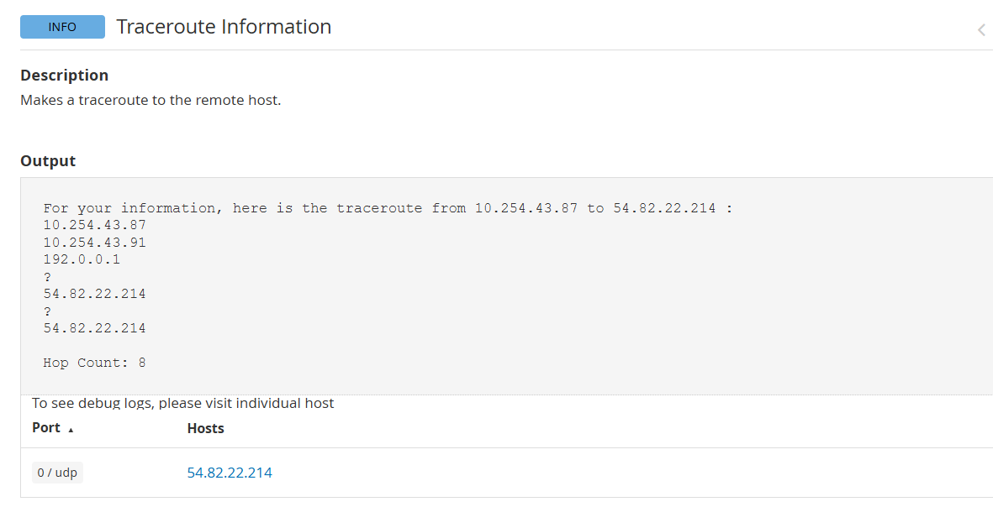

Stage – 3

Title of the project:
Integrate Zscaler with Identity Providers (IdPs) such as Azure AD, Okta, and Active Directory for seamless authentication and authorization.
SOC (Security Operations Center)
A Security Operations Center (SOC) is a centralized unit responsible for monitoring, detecting, analyzing, and responding to cybersecurity threats within an organization. In the context of our project, SOC plays a vital role in monitoring authentication events and access activities when Zscaler is integrated with Identity Providers such as Azure AD, Okta, and Active Directory. SOC analysts continuously observe logs generated by Zscaler and identity platforms to detect suspicious login attempts, unauthorized access, or abnormal user behavior. By using SOC monitoring, organizations can ensure that only authenticated and authorized users access secure applications through Zscaler, strengthening the Zero Trust security architecture.

SOC Cycle
The SOC cycle describes the continuous process used by SOC teams to maintain organizational security. The cycle includes several steps such as monitoring, detection, investigation, response, and improvement. In our project, SOC first monitors authentication logs from Zscaler and Identity Providers. When suspicious activity is detected, such as multiple failed login attempts or access from unusual locations, SOC analysts investigate the event. If the activity is confirmed as malicious, incident response procedures are triggered to block the user or device. Finally, SOC teams review the incident and update security policies to prevent similar attacks in the future.

SIEM (Security Information and Event Management)
SIEM is a security solution that collects, analyzes, and correlates security logs from multiple sources across the organization. In our project, SIEM collects logs from Zscaler, Azure AD, Okta, and Active Directory. These logs include user authentication attempts, access requests, system alerts, and network activity. SIEM tools help security teams identify suspicious patterns such as unauthorized login attempts, abnormal access times, or multiple authentication failures. By centralizing security logs, SIEM helps organizations detect threats quickly and respond before any serious damage occurs.

SIEM Cycle
The SIEM cycle involves collecting security data, analyzing events, detecting threats, responding to incidents, and improving security policies. First, logs from Zscaler and Identity Providers are collected into the SIEM platform. Next, the system analyzes the logs using correlation rules and threat intelligence. If suspicious behavior is detected, SIEM generates alerts for SOC analysts. After investigation, security teams take appropriate actions such as blocking users or updating security configurations. The final step is improving the detection rules to prevent similar threats in the future.

MISP (Malware Information Sharing Platform)
MISP is an open-source threat intelligence platform used for sharing cyber threat information between organizations. It allows security teams to collect, store, and share information about malware, attack techniques, and suspicious IP addresses. In our project environment, MISP can be integrated with SIEM to provide threat intelligence data related to malicious login attempts or compromised accounts. By using MISP, SOC teams can quickly identify known attack patterns and improve the detection capabilities of the security monitoring system.

Your College Network Information
In our college network environment, multiple systems are connected such as student portals, faculty systems, administrative applications, and internal servers. These systems must be protected from unauthorized access. By integrating Zscaler with Identity Providers such as Azure AD, Okta, and Active Directory, the college network can ensure that all users authenticate using centralized identity services. This allows secure access to applications while maintaining strict authentication and authorization controls.

How SOC Can Be Deployed in Our College
To deploy SOC in our college, security monitoring tools such as SIEM can be implemented to collect logs from network devices, servers, and identity platforms. The SOC team would monitor authentication logs, system activities, and security alerts generated by Zscaler and other systems. If a suspicious login or unusual access attempt is detected, SOC analysts can quickly investigate and respond to the threat. This helps protect student data, faculty information, and sensitive institutional resources from cyber attacks.

Threat Intelligence
Threat intelligence refers to information about potential cyber threats that can help organizations detect and prevent attacks. It includes details about malicious IP addresses, malware signatures, attack patterns, and hacker techniques. In our project, threat intelligence can be integrated with SIEM systems to improve detection of suspicious authentication activities. By using threat intelligence, SOC teams can identify known attack sources and block them before they compromise the network.

Incident Response
Incident response is the process used by security teams to handle cybersecurity incidents effectively. When a security alert is triggered by the SIEM system, SOC analysts analyze the event to determine whether it is a real threat. If a malicious activity is confirmed, actions such as blocking the user account, terminating the session, or restricting network access can be performed. In our project scenario, incident response helps prevent unauthorized users from accessing protected applications through Zscaler.

QRadar and Understanding the Tool
IBM QRadar is a popular SIEM tool used for security monitoring and threat detection. QRadar collects logs from multiple sources such as network devices, servers, applications, and identity providers. It analyzes the collected data using correlation rules to identify suspicious activities. In the context of our project, QRadar can collect authentication logs from Zscaler and identity platforms like Azure AD and Okta. This helps security teams identify threats such as brute-force login attempts, unauthorized access attempts, and suspicious user behavior.

Conclusion
Stage-1: In Stage 1, we understood the importance of web application security testing using OWASP Top 10 vulnerabilities. Identifying vulnerabilities such as XSS, TLS misconfiguration, and improper access control helps protect web applications from cyber attacks.
Stage-2: In Stage 2, we used the Nessus vulnerability scanner to identify security weaknesses in a target system. The Nessus report provided details about vulnerabilities such as outdated TLS protocols and server misconfigurations.
Stage-3: In Stage 3, we learned about SOC, SIEM, and QRadar dashboards used for monitoring security events. These technologies help organizations detect threats, monitor authentication activities, and respond quickly to security incidents.

Future Scope
Stage-1: Future web application testing will involve advanced automated security tools and AI-based vulnerability detection methods.
Stage-2: Vulnerability scanning tools like Nessus will continue to evolve with more advanced detection techniques and automated remediation capabilities.
Stage-3: SOC and SIEM platforms will integrate AI-based threat detection and automated response systems to improve cybersecurity defense mechanisms.

Topics Explored
- Web Application Security
- Vulnerability Assessment
- Security Monitoring
- Identity and Access Management
- SOC and SIEM Architecture

Tools Explored
- Nessus Vulnerability Scanner
- Zscaler Security Platform
- IBM QRadar SIEM
- Security Headers
- OpenSSL

The End

